# JSON Parsing in Apex by Salesforce Predator:

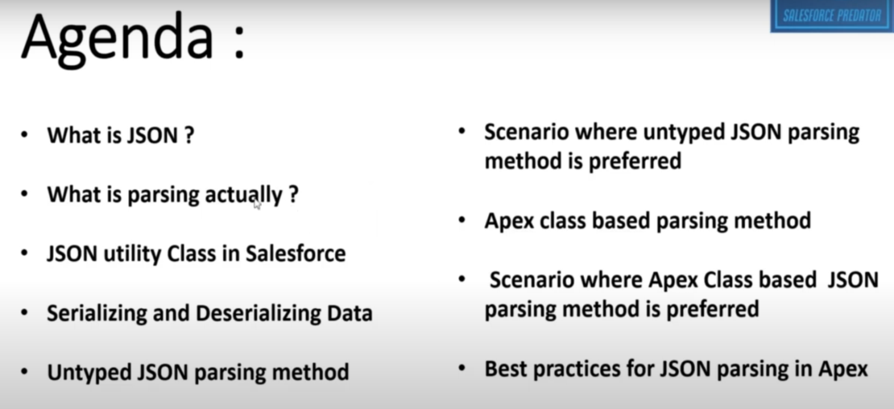

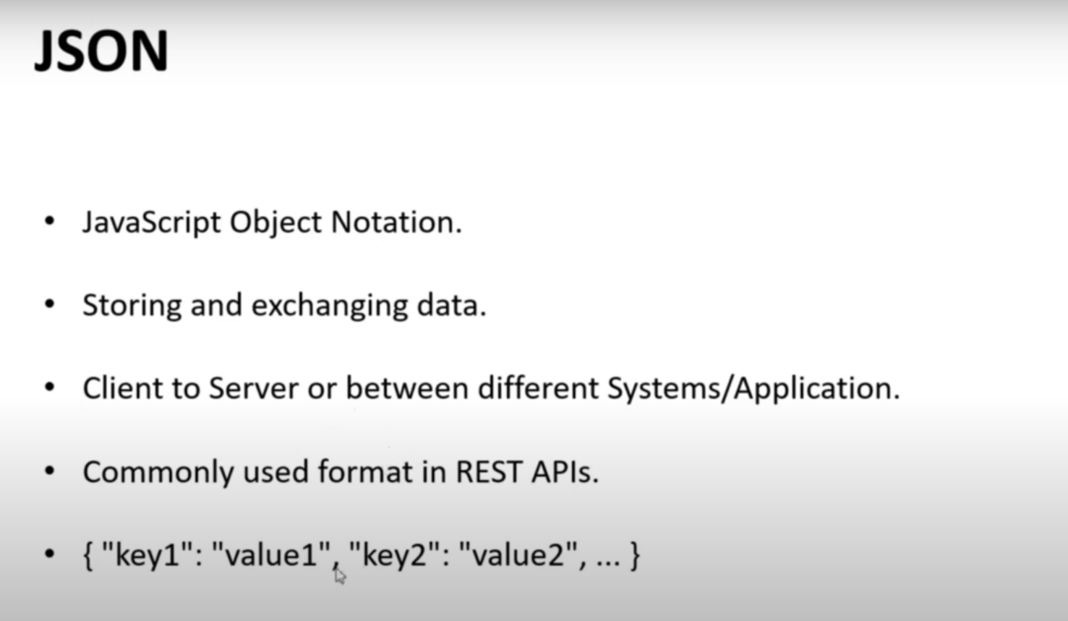

* What we mean by Parsing?
  + The process of converting a JSON string into data structure that can be easily managed and manipulated in apex.

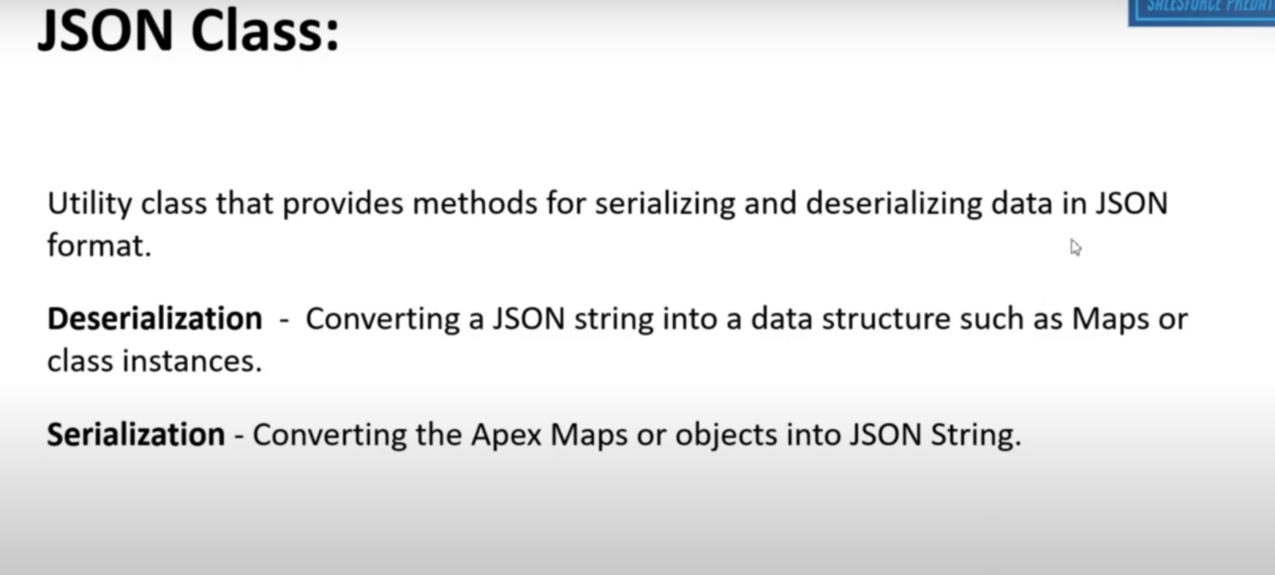

* <https://developer.salesforce.com/docs/atlas.en-us.apexref.meta/apexref/apex_class_System_Json.htm>
* Above link is reference of JSON methods.

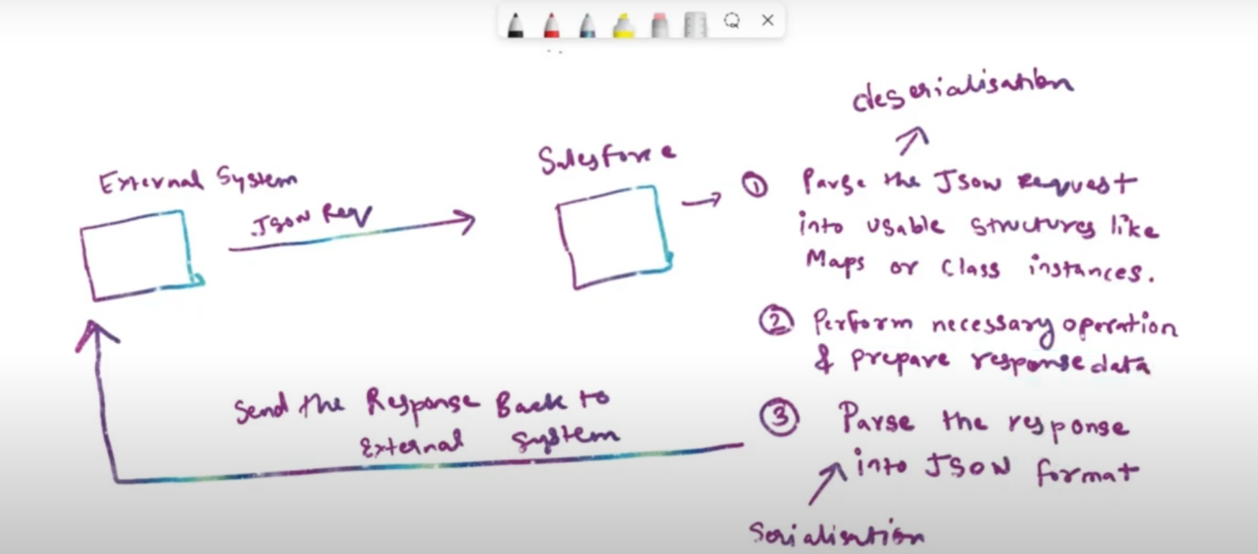

* There are two way to parse JSON:
  + Untyped JSON parsing method
  + Apex class based JSON parsing method

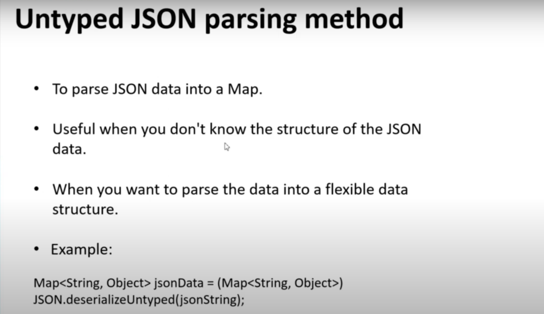

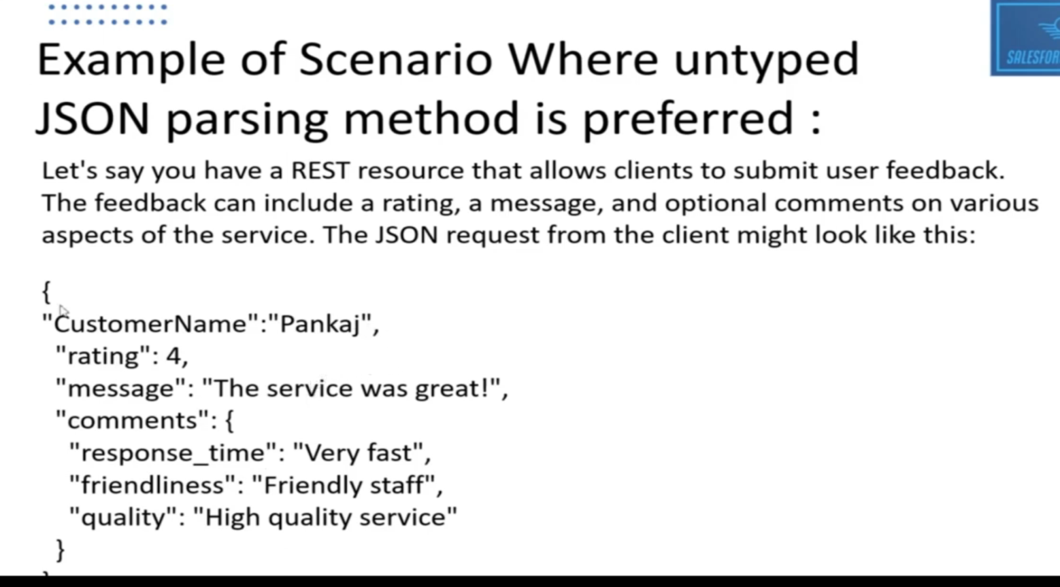

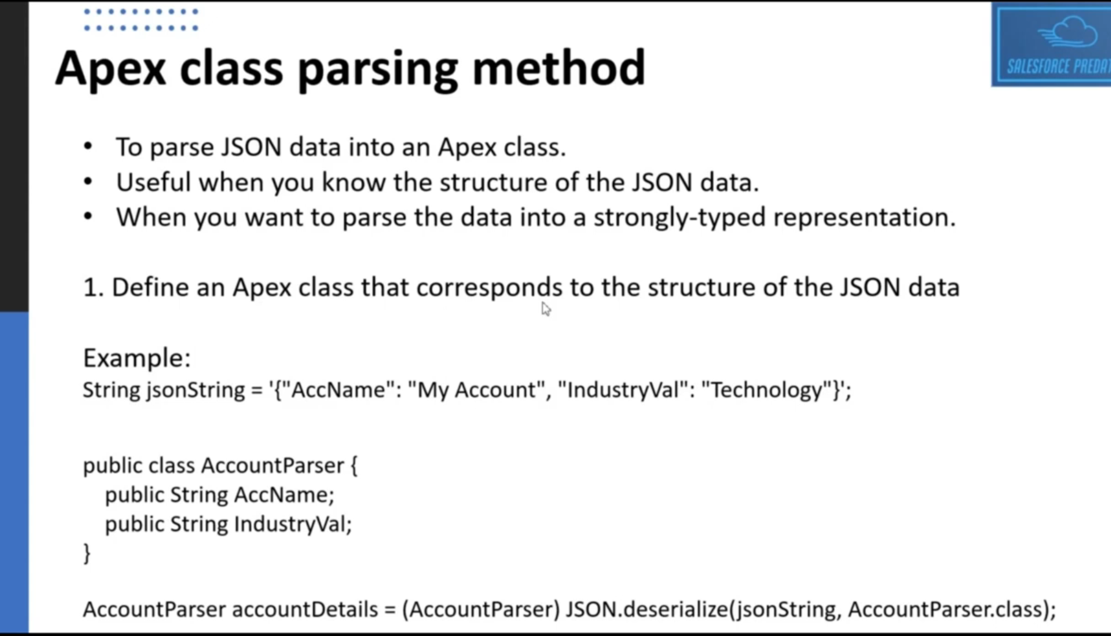

Note: AccountParser class has same name of the property as JSON property name. you can see “AccName” and “IndustryVal” is same in both the property.

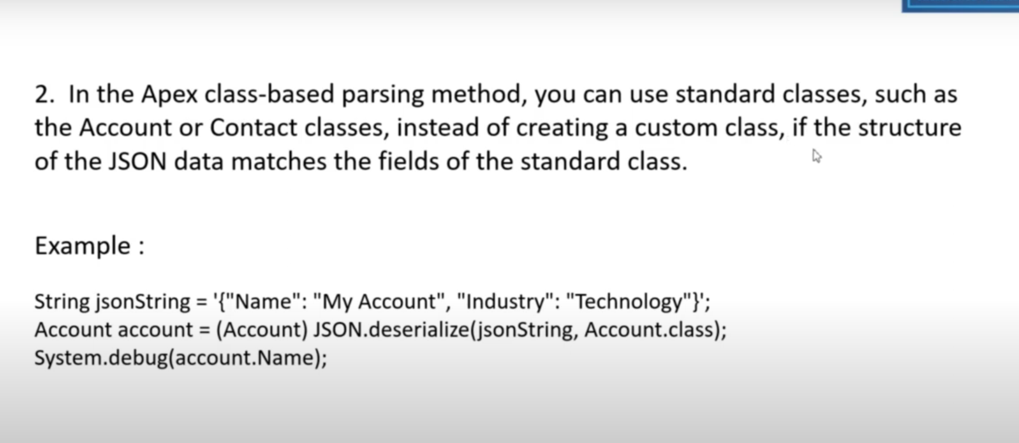

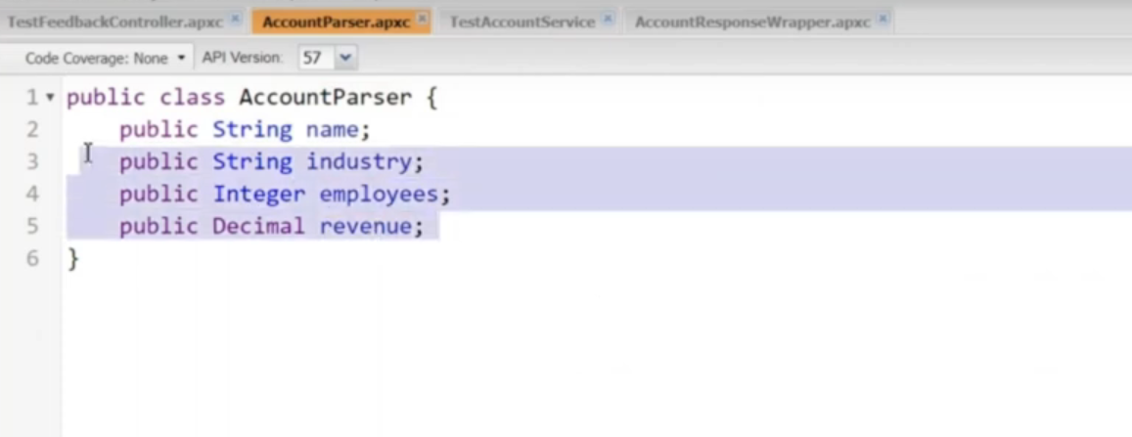

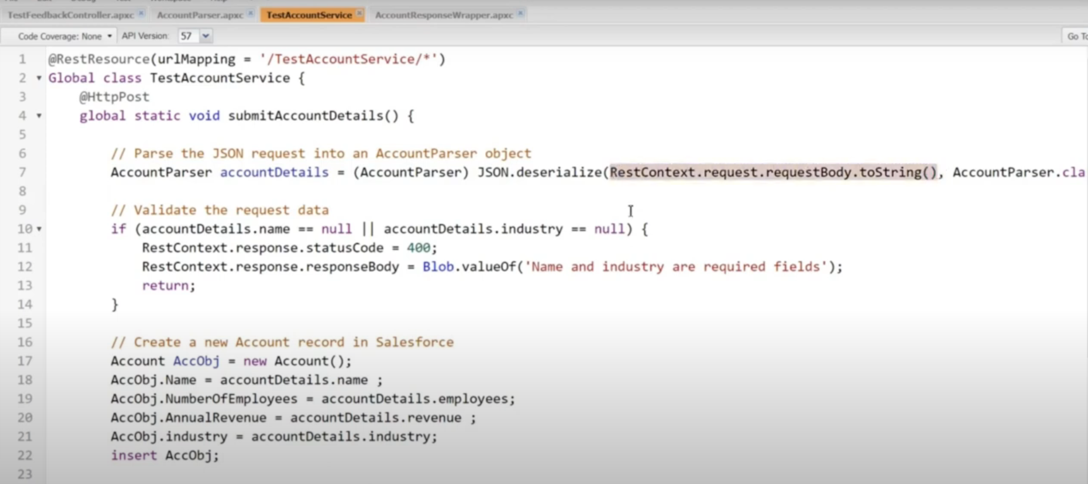

Part – 2 of above picture:

